Bishop Fenwick High School
Drama Club Presents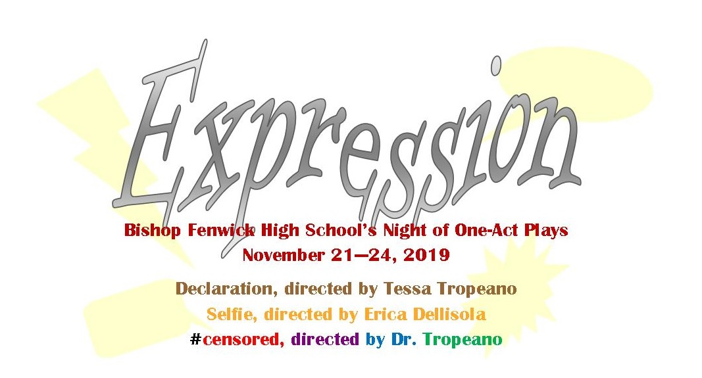Parent Handbook

Parent Letter Introduction

October, 2019
Introduction
Congratulations! Your son or daughter has been cast in the drama club’s fall presentation, a night of one-act plays called Expression. This past spring, we decided to bring one-acts to the stage that had a theme that was relevant to our lives today. The directors wanted to express something current and important, and that’s where we came up with the title Expression.
Show Dates
The performances are scheduled for Thursday, November 21st at 7:00pm, Friday, November 22nd at 7:00pm, Saturday, November 23rd at 7:00pm and Sunday, November 24th at 2:00pm. Students cast in #censored will also continue to have rehearsals in January and February, and will have an additional performance on Tuesday, February 25th. Students will then compete in the Massachusetts Educational Theater Guild (METG) Dramafest on Saturday, February 29, with the possiblity of going on to semifinals, and performing again on Saturday, March 14th, 2020. This is a much bigger time commitment than in years past and students need to make sure they are available for every rehearsal and performance.
Participation Fee
Each cast member is asked to pay a $50 show fee that will give each student the show tee shirt and cover the costs of the Spring Banquet. This may be paid online (https://www.fenwick.org/student-opportunities/performing-arts/theatre). If you choose to pay by check PLEASE have your cast member give the check to Ms. O’Dea.
Ads for Program
Parents and families are asked to financially support the program by selling ads for our program. We want our program books to be full of information and fun to read so please consider putting an ad in for a business or from a family member. Ads are due to Ms. O’Dea by February 24, 2020. You can make copies of the ad form found on page 17.
Meals for Cast during long rehearsals and for our field trip to Salem State
It has been a longstanding tradition that during our long rehearsals parents and family members provide healthy meals for our cast and crew. This is an invaluable service and the students and production staff look forward to these meals and are so grateful for the many hands that make them happen. Parents volunteer to set up, bring food, and clean up. Ms. O’Dea handles the planning of this.
Performing Arts Banquet May 28, 2020 7:00pm
All students involved in the theater and choir are invited to this fun end-of-the-year banquet, with a build your own ice cream sundae buffet. Look for more information in the Spring. Every year at the banquet, seniors are recognized with a senior gift; students who have been in 3 or more shows are recognized with a Fenwick letter; the critiques from the Massachusetts Educational Theater Guild are read; production staff give out awards; Concert Choir section leaders are announced; and the production schedule for the following year is announced, including the announcement of student directors. This is a fun night, and even though it is an inredibly busy time of year, we make time for this so that our well deserving students can be recognized. We will be looking for parent volunteers to help so please let us know if this interests you.

Parent Committee Opportunities
Parent communication and involvement are essential! Without the support of parents, shows like this could not happen! We know that you parents are the ones who are driving and picking up from rehearsals, picking up important costume, prop, or makeup pieces, and helping to promote our show by hanging posters, buying tickets, and spreading the word on social media. Please like and follow our facebook page if you haven’t already: www.facebook.com/fenwickperformingarts. By working together, we make our Drama Club a special place to be – a place where all students are welcome; and where all students are encouraged to explore and create through the performing arts. Regardless of grade level or experience, the students build lasting friendships and create life-long memories.
Parents are expected to volunteer in one of the areas, as well as help sell ad space in our program, sell tickets for the shows, and promote the shows on social media. Parents are expected to attend the parent meeting on October 8th at 7:00pm in the lobby of the auditorium.
Committee Contact Person
Costumes Ms. Foley
Hair & Makeup Ms. Foley
Publicity/Program Ms. O’Dea
Ticketing Ms. O’Dea
Set Building Mr. Berube
Meal Planning Ms. O’Dea
Concessions Ms. O’Dea
Cast Party Ms. O’Dea
Banquet Dr. Tropeano
Communication

Once your student is cast, they are to join their group on the Fenwick app.
Production information will be transmitted/posted through the app only. Personal communication with the production team should be made via email:
Dr. Tropeano, Director KST@fenwick.org
Ms. O’Dea, Producer KAO@fenwick.org
Ms. Foley, Costume Manager LPF@fenwick.org
Mr. Berube, Set Director Ktberube@gmail.com
Mr. Cox, Technical Director TPC@fenwick.org

Important Dates
Mon. Sept. 20 Completed Commitment Form returned to Dr. T
Tue. Sept. 24 Auditions 6:00pm
Wed. Sept. 25 Auditions 3:00pm
Fri. Sept. 27 Cast List Posted
Mon. Sept. 30 Mandatory Cast meeting 6:00pm
Tue. Oct. 8 Parent Meeting 7:00pm
Fri. Nov. 1 Participation Fee Due
Nov. 4-6 Wahlburgers Fundraiser, TBA
Wed. Nov. 6 All Costume pieces in, with laundry basket
Wed. Nov. 6 Off-Book completely, no scripts allowed
Fri. Nov. 8 Ads due for program
Sat. Nov. 16 Super Saturday Rehearsal 9am-1pm Selfie
Sat. Nov. 16 Super Saturday Rehearsal 1pm-5pm Declaration
Sun. Nov. 17 Super Sunday Rehearsal 1pm-5pm #censored
Mon. Nov. 18 Selfie Final Tech Rehearsal 3pm-9pm
Tue. Nov. 19 Declaration Final Tech Rehearsal 3pm-9pm
Wed. Nov. 20 #censored Final Tech Rehearsal 3pm-9pm
Thu. Nov. 21 Daytime Show, 9:15am, no classes
7:00pm Show
Fri. Nov. 22 Students can wear show t-shirts to school
7:00pm Show
Sat. Nov. 23 7:00pm Show
Sun. Nov. 24 2:00pm Show
Mon. Nov. 25 6:00pm SET STRIKE
Tue. Feb. 25 Dramafest brush-up performance, location TBA
Sat. Feb. 29 Dramafest for #censored cast & crew
Sat. Mar. 14 Dramafest semifinals (TBA)
Thu. May 28 Performing Arts Banquet

Costumes
Because all of the one-acts have a contemporary setting, we’re going to ask the students to provide most of their own costumes, preferably from their own closets, borrowed from a friend or bought from a discount store like Savers. Ms. Foley, our costume manager, will have more specific instructions once we’re in rehearsals. Along with the costumes, please also provide a laundry basket to keep all your student’s costume pieces in, and please put their names in every costume piece.
Tech Week November 16-21
“Tech Week” is the final week leading up to the performances. This is when all of the pieces of the show come together, including costumes, lights, microphones, sets, and orchestra pit. The three casts will practice separately on the stage with the tech crew. This is the schedule:
Saturday, November 16 for Selfie (9am-1pm) and Declaration (1pm-5pm) and Sunday, November 17, 1-5pm for #censored.
Monday, November 18, 3-9pm Selfie
Tuesday November 19, 3-9pm Declaration
Wednesday November 20, 3-9pm #censored
Ms. O’Dea will work with parent volunteers to provide dinner for the students and staff. These are long nights so students should bring snacks and plan to do homework when they’re not needed on stage.
Shows (November 21-24, 2019)
Thursday, November 21: All cast/crew students are excused from classes on Thursday, November 21st. Students must attend homeroom, wearing “Dress-down” appropriate clothing. After homeroom, students meet in the gym to get ready for an “open dress rehearsal” for local middle schools. Students will stay in the theater for the whole day, lunch will be provided. This is just like a school day so all school rules must be enforced. Students cannot leave the school building or have their cell phones out for any reason. Students will be dismissed at the end of the school day. Students must report back to the theater at 5:00pm; opening night is at 7pm. Cast and Crew only are allowed in the cafeteria/dressing room. Please respect this rule and meet your students in the lobby after the show. Students cannot leave the theater after the show until all props and costumes are set for the next performance and all dressing areas (gym, cafeteria, backstage, etc) are cleaned.
Friday, November 22: Students may wear the show shirt with uniform pants to school. Students must be in school to perform in the show. Students must report back to the theater at 5:00pm; performance at 7pm. Cast and Crew only are allowed in the cafeteria/dressing room. Please respect this rule and meet your students in the lobby after the show. Students cannot leave the theater after the show until all props and costumes are set for the next performance and all dressing areas (gym, cafeteria, backstage, etc) are cleaned.
Saturday, November 23: Show is scheduled for 7:00pm, and students must arrive at theater at 5:00pm. The same performance rules apply for this night.
Sunday, November 24: Call time for students is 12:30. Everything must be moved from the cafeteria for school to start on Monday. This clean-up will take more time. Students cannot leave until Dr. Tropeano dismisses them. If everyone works together, this should not take long.
Set Strike November 25 6:00pm
All students (Cast and Crew) are expected to be at Strike. This is when everything from the musical is disassembled and thrown out or put into storage and the stage, auditorium, and balcony are completely cleaned. This is a lot of work, but the more people there to help the better.

Performing Arts Banquet May 28, 2020 7:00pm
All students involved in the theater and choir are invited to this fun end-of-the-year banquet, with a build your own ice cream sundae buffet. Look for more information in the Spring. Every year at the banquet, seniors are recognized with a senior gift; students who have been in 3 or more shows are recognized with a Fenwick letter; the critiques from the Massachusetts Educational Theater Guild are read; production staff give out awards; Concert Choir section leaders are announced; and the production schedule for the following year is announced, including the announcement of student directors. This is a fun night, and even though it is an incredibly busy time of year, we make time for this so that our well deserving students can be recognized. We will be looking for parent volunteers to help so please let us know if this interests you.

Dramafest Schedule
The students involved in Dr. Tropeano’s show #censored will continue to have rehearsals throughout January and February. Students will rehearse weekly and then will have a performance for the public. Students must be able to commit to all of the rehearsals and performances so please make sure you can attend all of these before committing to the dramafest show. Please make note of these important rehearsals and performances:
Monday, January 13th 6:00pm Rehearsal
Monday, January 27th 6:00pm Rehearsal
Monday, February 10th 6:00pm Rehearsal
*One additional rehearsal during February Break
Tuesday, February 25th 7:00pm, Performance offsite, location TBA
Tech Rehearsal at Dramafest site TBA
Dramafest Preliminary Round, location TBA, February 29th, 8am – 10pm
Dramafest Semifinals, Location TBA, March 14th, 8am – 10pm

