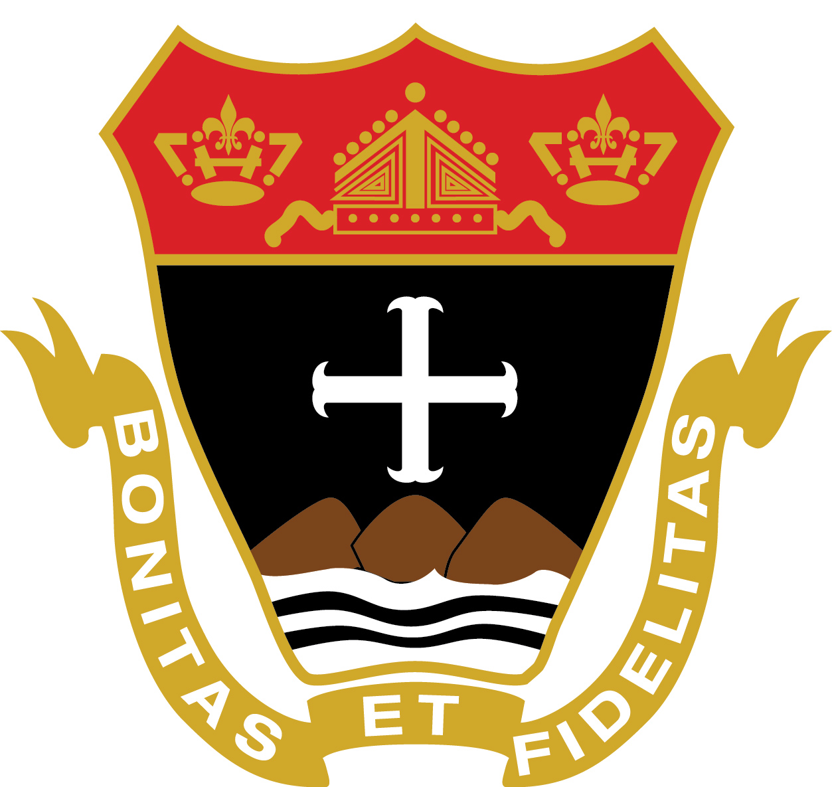
Fenwick Faculty and Staff
Update for 2020-21 Academic Year

Meet the New Team Members!

As we begin the new school year, I am pleased to share with you this comprehensive update regarding our Fenwick Team. We are thrilled to have assembled such an extraordinary group of educators and we are blessed to have such a remarkable learning community. We know that you will be impressed by the newest members of our faculty and staff, as well as by those returning members who are moving into new positions. Please join me in congratulating all of these individuals for “stepping up” for Fenwick!

Administration: Familiar Faces, New Roles
Mr. Dave Dugan, Dean of Student Life: As we considered how best to move forward with our administrative structure, it was equally obvious that Mr. Dugan would be ideal in this role. Mr. Dugan will continue as Social Studies Department Chair; he’ll teach two classes and he will also continue to coach football (where he is a most inspiring mentor). Mr. Dugan will assume the responsibility of many aspects of the student experience at Fenwick: conduct and behavior, involvement and participation. Mr. Dugan will handle all major disciplinary matters at Fenwick. In his new role, Mr. Dugan will focus on leadership, helping to inspire greater student engagement in sports, clubs, and activities. Mr. Dugan will work closely with Mrs. Faragi in Health & Wellness, especially this year, and with Mr. Woods in Athletics, and he will be a member of the Academic Support Team. With Mr. Canniff, he will help to address issues related to attendance and to dress code; together, they will lead the Class Moderator program. Mr. Dugan’s passion, presence, and perspective will be transformative!

Mr. Chris Canniff, Assistant Dean of Student Life: In our effort to develop a more distributed model of leadership, it was obvious that Mr. Canniff would play a key role. Mr. Canniff will continue as Theology Department Chair; he’ll teach two classes and he will also continue to lead our Student Activities Council (where his contributions are obvious to all). In his new role, Mr. Canniff will focus on scholarship, working with Ms. Marquez on grade reports, academic trends, etc., and working with our College & Guidance Counselors in the college process. Mr. Canniff will be investing his time particularly with the 9th grade, ensuring their smooth transition to Fenwick, as well as being a conduit for areas of school life such as Campus Ministry and Student Activities Council. With Mr. Dugan, he will address issues related to attendance and to dress code; together, they will lead the Class Moderator program. Mr. Canniff’s passion for faith, virtue, community, and excellence will shine here!

New Team Members

Mr. John Barry, Social Studies: With an MA in History from the College of the Holy Cross and an MEd from UMass Boston, Mr. Barry is exceedingly well-prepared for the classroom. Mr. Barry’s wonderfully approachable presence will be obvious to all of his students. Mr. Barry has experience teaching at a variety of grade levels—from elementary and middle school to, most recently, Melrose High School—and he is particularly enthusiastic about working with high school students. A graduate of BC High, Mr. Barry genuinely understands and appreciates our mission, and he looks forward to being immersed in our faith community.

Ms. Katie Conroy, College Counseling & Guidance: Many of you already know Ms. Conroy because she was our long-term substitute last spring in our College Counseling & Guidance Department. She did a fantastic job in this capacity and we are excited to keep her at Fenwick. Ms. Conroy has a BS in Sociology from Suffolk University, an MEd in School Guidance from Cambridge College, and guidance experience at a number of schools on the North Shore. Ms. Conroy has been looking for “just the right fit” in a school community and now she’s found it; she is also the proud parent of an incoming member of the Class of 2024!

Ms. Briana Maund, Theology: A recent graduate of Notre Dame University where she earned her MA in Theological Studies, Ms. Maund is also a Cum Laude grad of Boston College where she minored in French and earned a BA in Theology. With a passion for the study of theology—from Biblical studies to philosophical foundations—Ms. Maund looks forward to starting her teaching career at Fenwick. Ms. Maund will be teaching Grades 9-11 and assisting with Campus Ministry. Ms. Maund, like many of us at Fenwick, loves Augustine’s Confessions, and she is excited to share both the intellectual and spiritual dimensions of her faith.

Mr. Bill McMurray, Director of College Counseling & Guidance: Most recently a regional admissions rep for Roger Williams University, Mr. McMurray served in a variety of admissions roles at Wheaton College. A veteran college counselor who has elevated programs in high schools (St. Sebastian’s, BU Academy) and colleges, as well as done his own consulting work in the college admission/financial aid process, Mr. McMurray has a passion for helping each student find the very best next school for her/him. Mr. McMurray earned his BA in Psychology from Bates and his MEd from the University of Vermont, and he is thrilled to be at Fenwick!

Ms. Kyra McDermott, Mathematics: Having recently graduated Magna Cum Laude from Syracuse University with an MS in Mathematics, Ms. McDermott developed a passion for mathematics as a high-achieving student at Reading HS. Ms. McDermott was a three-year member of the Renee Crown Honors Program at Syracuse where she also tutored high school students; her intellectual acuity is matched only by her personal presence, and she will be a great addition to Fenwick. Ms. McDermott will be teaching two or three sections of Math as well as providing additional support for our team by proctoring and covering classes.

Ms. April Monchik, Science: A product of Northfield Mount Hermon School with a BS in Chemistry from Skidmore College and an MS in Biology from New York University, Ms. Monchik is a veteran science teacher with experience in Biology, Chemistry, and Physics. Most recently at Winchester HS, and previously at high schools including New Mission, Newburyport, and Belmont, Ms. Monchik has also done medical and scientific research at Ivy League institutions. With a variety of interests from field hockey to yoga, Ms. Monchik will teach mostly Chemistry this year; she truly looks forward to joining our team and serving our students.

Ms. Laura Romano, Math: With her BA in Mathematics and her MAT in Mathematics, both from Salem State, Ms. Romano is an exemplary Math teacher with experience at the high school and college level. Ms. Romano has taught all levels of mathematics at a variety of institutions including Lynn English HS, Georgetown HS, Merrimack College, Endicott College, Salem State, and community colleges. The most important school on her resume is Bishop Fenwick—she is a proud Class of ’96 Fenwick alum! Ms. Romano is thrilled to return to Fenwick. She has a particular affinity for statistics, and she will be teaching a variety of Math courses.

New Titles/Responsibilities

- Mr. Steve Driscoll, Admissions Director
- Ms. Erin Good, Director of Academic Support
- Ms. Paula Hannon, Assistant Athletic Director and Assistant Admission Director
- Ms. Roza Mazzeo: Chair of Diversity, Equity, and Inclusion Committee
- Ms. Joan Rich, Administrative Assistant for Admissions (part-time)
- Mr. Nick Twaalfhoven, Theology Teacher (now full-time)

Class Moderators

We are moving to a more distributed model of leadership, striving to develop the many gifts and talents of our faculty members and also to create a better educational experience for our students. Specifically, we are hoping to create a more consistent connection and a more cohesive community within each grade level.

This will help to advance our mission of providing a holistic education that serves the needs of each individual student. We are confident that stronger unity and camaraderie within each class will also help to address the social/emotional/relational health needs of our young people. Finally, we know that the positivity and presence these role models bring to our community will make a difference!

Please welcome the following faculty members as Class Moderators for 2020-21:
- Class of 2021: Ms. Julie Hart and Mr. Dave Dugan
- Class of 2022: Ms. Marybeth Mahoney and Mr.Joe MacKay
- Class of 2023: Ms. Kelly O’Dea and Ms. Kylie Homem
- Class of 2024: Ms. Jena Timson and Mr. Chris Canniff

