**English III Honors: Summer Reading**

**Community Read**: ***A Thousand Beginnings and Endings*** 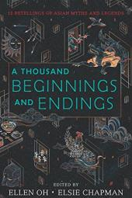 **edited** **by Ellen Oh.**

**Assignment #1:**  The Community One Read this summer is ***A Thousand Beginnings and Endings edited by Ellen Oh.*** Please see the Fenwick website for information about the One Read book and the two-part reading assessment project instructions.  The summer reflection project assignment will be graded and will count as a first quarter religion grade.

**Assignment #2:** In addition to the community read, each ENG III Honors student needs to read the two (2) books listed below and complete the assignment. Note: ENG III CP & CP-A have a separate reading list.

Please read both of the following:

1. *Frankenstein* by Mary Shelley .

2. *Grendel* (John Gardner)

When you enter Fenwick in September, you will be tested on your reading which will include a writing assignment. Make sure that you do close reading which may include highlighting, using sticky notes or writing down important notes from each chapter.